**Technical Summary: Face Recognition Under Challenging Conditions**

**(COMSYS 2025 Hackathon - Task B)**

**Objective**

The project aims to train a ResNet-50 classifier to extract embeddings for each identity. Validate performance using cosine similarity between distorted images and clean reference images. And evaluate with Accuracy, Precision, Recall, F1-Score for both train and validation datasets.

**Approach**

1. Data Preparation: Uses a custom FaceRecognitionDataset to load clean and distorted images
2. Model Architecture: Based on ResNet-50 pretrained model. All layers frozen except layer4 and fc.
3. Training: Uses CrossEntropyLoss with label smoothing.
4. Saving Model
5. Evaluation: Accuracy, Precision, Recall, F1 Score

**Architecture Overview**

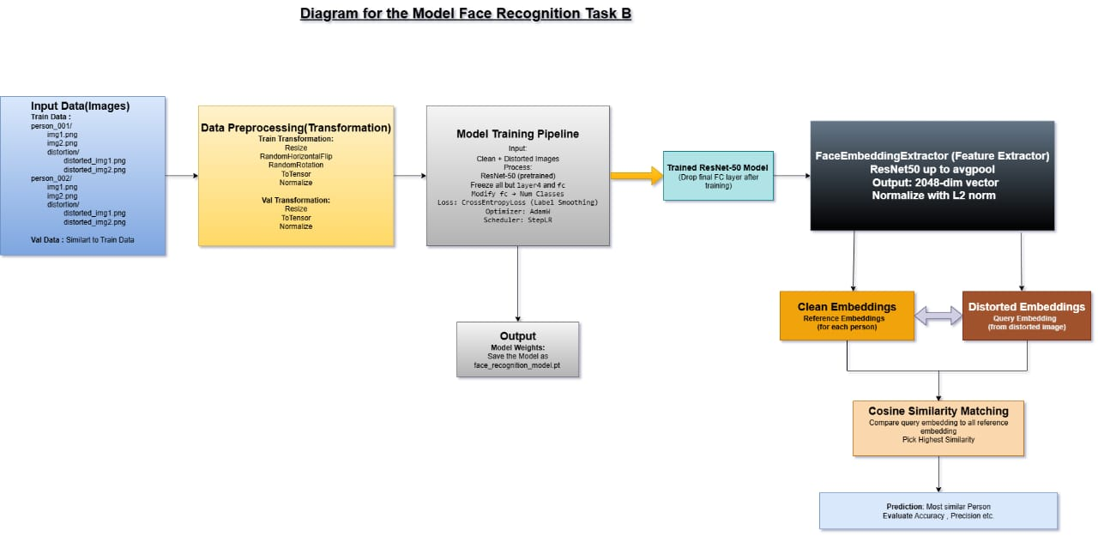

**Innovations**

The project uses ResNet-50 to extract facial embeddings and compares them using cosine similarity, enabling robust identity matching even under image distortions. This flexible, real-world-ready approach is evaluated with Accuracy, Precision, Recall, and F1-Score on both clean and degraded datasets.

**Conclusion**

Our system combines data-centric design, lightweight deep learning, and real-world resilience to estimate age groups accurately even when the face is imperfectly captured. It’s built not just to score on benchmarks — but to work in the wild.